SCENARIO: HIVEBALL STREET RULES
During a drunken night at the local settlement two gangs challenge each other to a match of Hiveball, but none of these pansy up hive rules no this time is Street rules!

BATTLEFIELD
This scenario uses a custom battlefield set up as shown below. The special rules for the Centre tile are ignored for this game.
CREWS
This scenario uses the standard rules for choosing a crew, as described on page 22 of Gang War 1. Both player use the Custom Selection method.
TACTIC CARDS
Each player has the Improvised Armour Tactic card and once per turn may use the Adrenaline rush tactic card.
DEPLOYMENT
The winner of a roll off picks a half of the battlefield and sets up five fighter from their crew in their side of the battlefield, if possible at least half (rounded up) the models on the field at any time must be gangers or Juves. Only 3 may be within 1” of the centre line and the other two must be at least 6” away from the centre line. Once the first player has set up their crew the second player sets five fighters from their crew up in the other half of the battlefield following the same restrictions about their fighter’s proximity to the centre line. After the second player has set up the player who won the original roll off places a marker representing the ball anywhere within 1” of the centre line, the ball then scatters D3”. If a hit is rolled and the ball was on a fighter, they can immediately make an initiative test to catch the ball. If they succeed the fighter receives the ball marker if they fail the ball scatters in the direction of the arrow on the hit dice following the rules for a bouncing ball. Each player then Sets up a loot crate as depicted on the diagram below. After 8 turn the half ends and players follow the deployment instructions again.
OBJECTIVES
The Objective is to get as many balls in your opponent’s loot crate. Once a fighter moves into contact with the opponent’s loot crate the ball is automatically placed within it. Once this happens the fighter’s activation automatically ends, and the players roll off, the winner places another ball following the rules for ball placement in the deployment section.
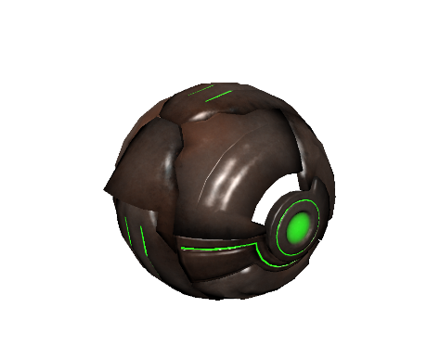
ADDITIONAL HIVEBALL STREET RULES
There are several additional rules used when playing Hiveball even when street rules are in effect.

WERE ALL A LITTLE DRUNK
Being drunk effects the fighters in Four ways.
1) Each fighter may only make a single action per activation rather than two.
2) A fighter may move within 1” of an enemy fighter and become engaged with them using a regular move action as well as a charge action, though if a regular move is used they do not receive the free Fight action.
3) Fighters can use the Retreat action as a free action once per turn should they succeed how ever they only move 1” directly away from the enemy fighter they are retreating from and can then continue their activation. Also, unlike a normal retreat then the enemy dose not get the chance to strike the retreater, they only get this chance if the retreat is failed
4) bottle tests do not need to be made, but should a gang voluntarily bottle then that gang will count as having D6 more balls placed in there Loot crate by the opposing team.
SUBS
Should one or more fighter be removed from the field. At the start of the next turn a member of your gang can join the action. Place fighters within 6” of your loot create until you have 5 fighters on the battlefield. if possible at least half (rounded up) the models on the field at any time must be gangers or Juves. These new fighters are readied this turn.
INJURY & FOULING
A player that is seriously injured during the recovery phase is always considered to have a friendly fighter within 1” due to the rest of the gang and onlookers cheering for them. Should a fighter go out of action, roll for injury as normal. Should any fighter take any form of cupe de grace action to take another fighter out of action the other team can call a foul and roll a D6 and consult the table below
D6 Result | Effect
1-2 | No one cares play continues.
3-5 | The fighter is booed and jeered off the battlefield by the onlookers and is removed from the battlefield and added to your subs. A sub may not be brought on to fill this gap in your team for D3 turns. Subs for out of actions can still be brought on.
6 | As above but the space may not be filled until the gangs redeploy after turn 8.

BOUNCING BALL
Any time the ball scatters the following rule Is used. Should the ball marker come into contact with a fighter then the scatter ends, and the fighter makes an initiative test, if the test is passed then they receive the ball marker. If it fails, the ball scatters D3” from the fighter.
THROWING AND CATCHING
Now although the term ball is used it can be anything from an actual ball to a piece of random junk so throwing it in the confines of the Underhive can be hard. When a fighter has the ball, they can take the Following Action.
TROW BALL[Simple]
A fighter can throw the ball to a spot or to another fighter, if they throw the ball to a spot the controlling player should declare a spot within 18” of the fighter with the ball. They then make a BS check with a -1 Modifier for each 6” of the throw and each enemy fighter within 1” of the throwing fighter. When the ball lands it will Scatter D3” + 1” for each point the BS check failed by (for example if a fighter throws a ball and need 4+ to hit, if they roll a 2 the ball would scatter D3” + 2”). If a fighter throws to another fighter then they select a fighter within 18” and they make a BS check with a -1 Modifier for each 6” of the throw and each enemy fighter within 1” of the throwing fighter. Then the fighter receiving the ball makes an Initiative test with the following Modifiers.
-1 If the BS check Failed.
-1 if the Dice of the BC check rolled a natural 1.
+1 if the BS check Succeeded.
+1 if the Dice of the BC check rolled a natural 6.
If the Initiative check succeeds then the fighter catches the ball and receives the ball marker, if it fails then the ball scatters D3” inches from the fighter.
INTERCEPTION
Whenever a ball is thrown should the line between the centre of the throwing fighters base and spot/centre of receiving fighters base pass over any point in another fighters base then that fighter can make the following Reaction.
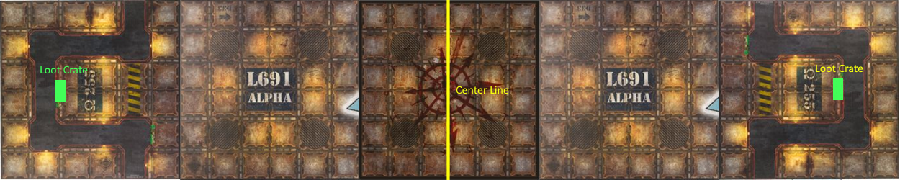
INTERCEPT
this action interrupts a THROW BALL[Simple] Action after the BS check has been made, the fighter attempting the intercept makes an initiative check with the following modifiers
+1 If the BS check Failed.
+1 if the Dice of the BC check rolled a natural 1.
-1 if the BS check Succeeded.
-1 if the Dice of the BC check rolled a natural 6.
if the Initiative test is a success then the intercepting player receives the ball token and the THROW BALL[Simple] action ends, if the test fails then the THROW BALL[Simple] action continues un effected. If a natural 1 is rolled the player attempting the intercept becomes pinned.
ENDING THE BATTLE
After the 16th turn has been played or there are only models from one gang left on the battlefield the game comes to an end.
VICTORY (SKIRMISH ONLY)
The player whose gang has placed the most balls in their opponents loot crate is the winner, if the both gangs have placed the same amount of balls in loot crates it is a draw.
Battlefield Setup
REWARDS (CAMPAIGN ONLY)
CREDITS
The gang who placed the most balls in their opponents loot crate received D6 x 10 Credits From betting on the game, Should the score be tied then each gang receives D3 x 10 credits.
EXPERIENCE
Each fighter that took part in the battle earns 1 XP.
A ganger that place a ball in the opponents loot crate receives 1 XP (this is only a single XP for the game not one per ball this fighter placed in the loot box)
If a gang scored more points than the other then the leader of that gang gains 1 XP
REPUTATION
Each gang gains 1 reputation if this was their first battle against this opponent.
If one gang placed more balls in their opponents loot crate then they receive reputation equal to ½ (rounded up) the difference between the two scores.
If either gang bottled out they lose 1 reputation.

