

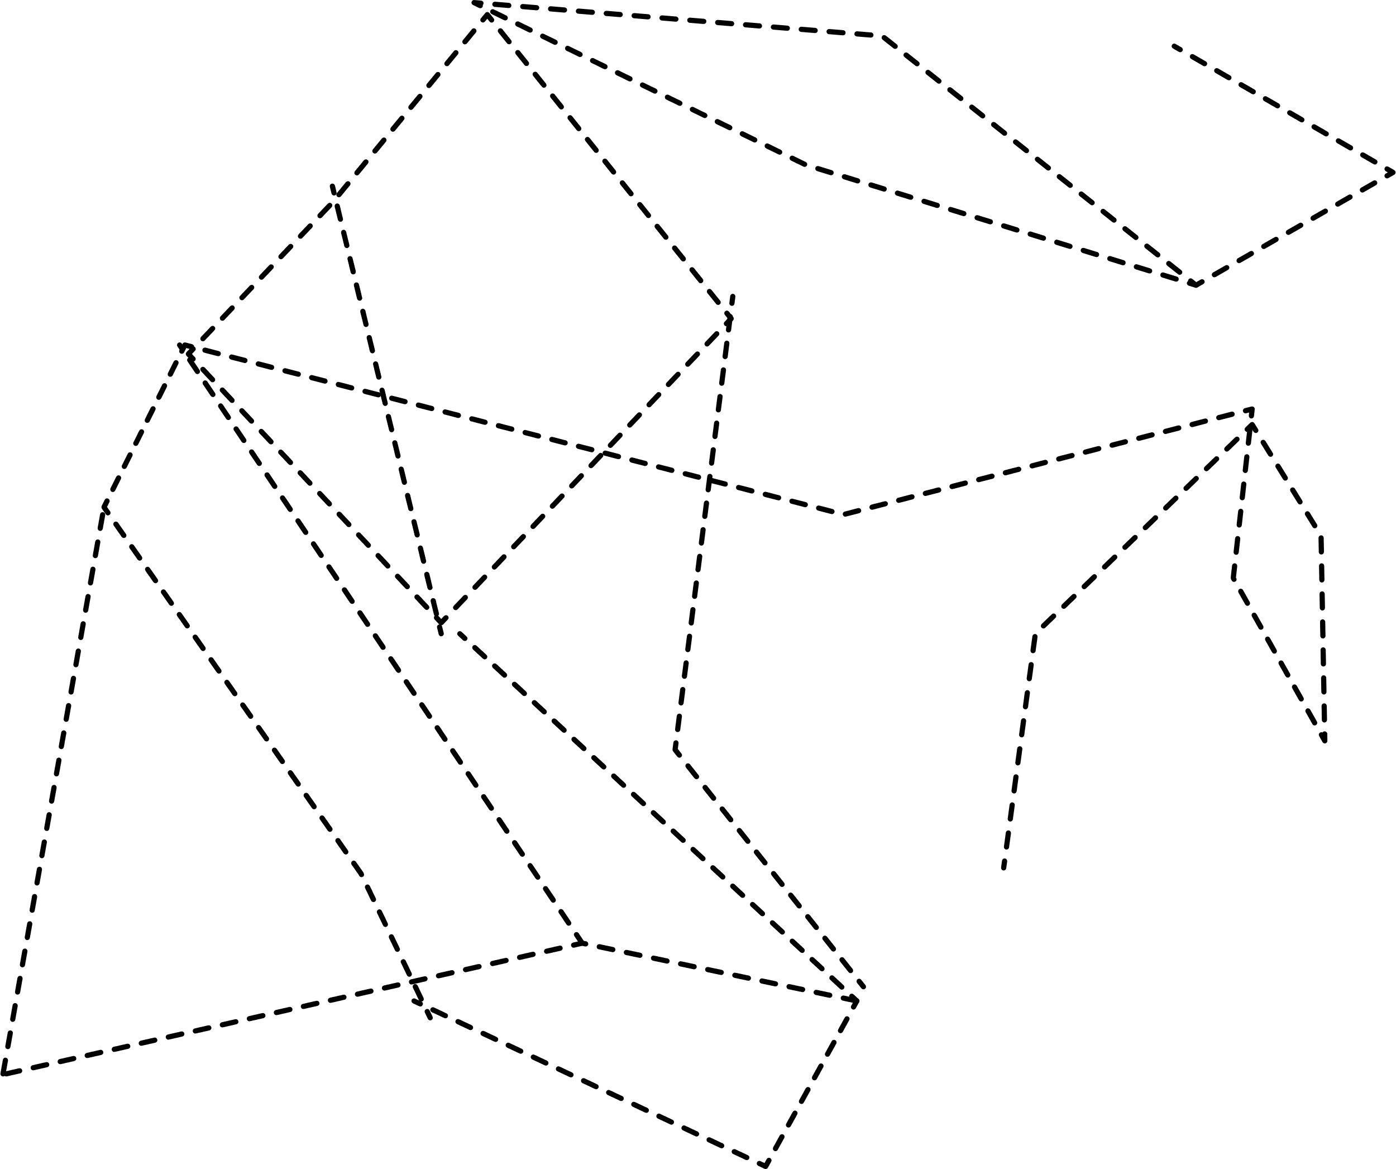
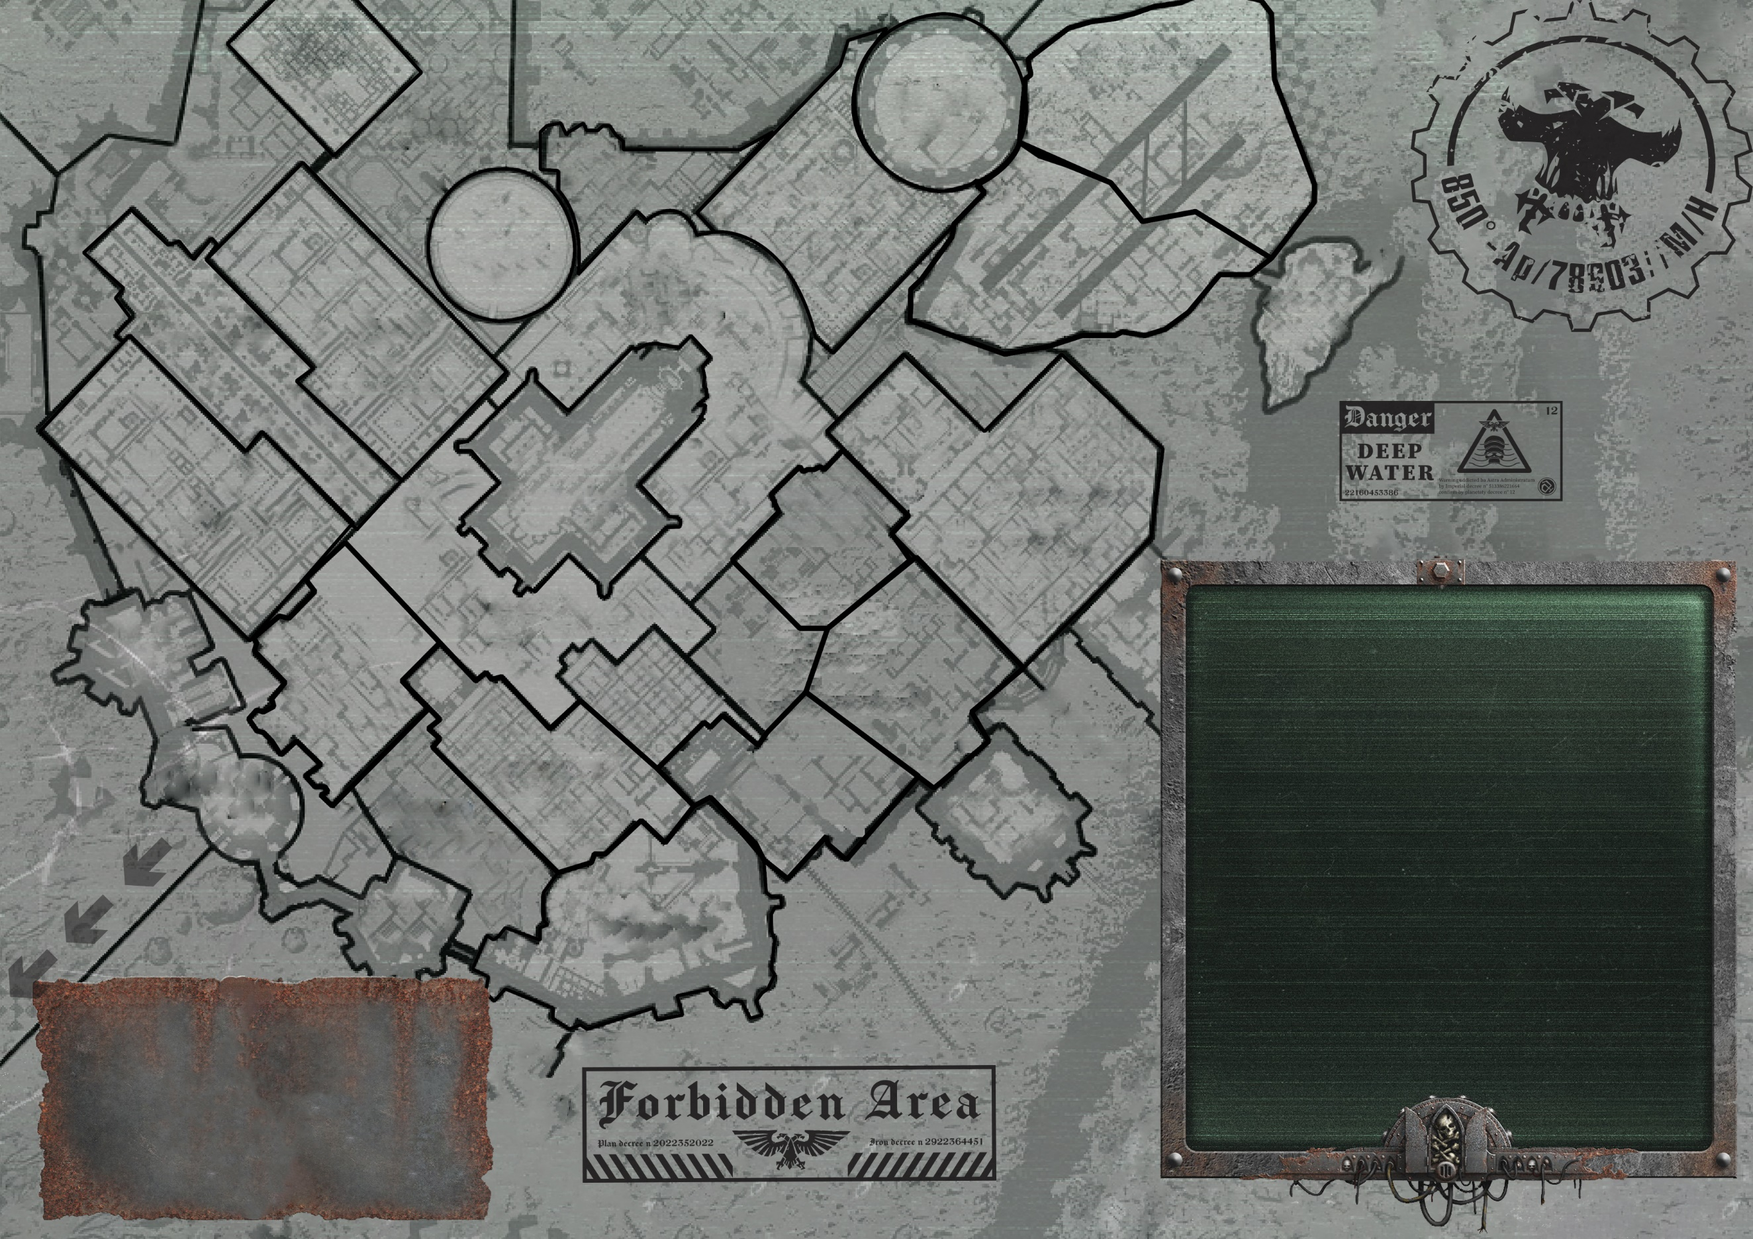
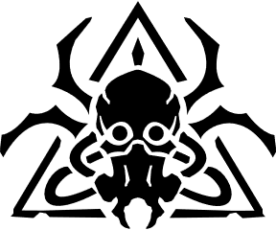


WATER GUILD BOND
STATUS RAPORT

++xxxxxxxxxxxxxxxxxxxxxxxxxxx

THIS MAP INCLUDES ALL RACKETS, BUT FOR
UNUSED RACKETS YOU CAN USE THIS ICON

You can take icons from there
And move them to the bottom box.
They can also be couloured, if more
Than 1 player has the same gang either
By changing colour or (more elegant
way) by changing glow colour
GANGS ACTIVITY

Escher Goliath

Palanite Enforcers Cawdor

Delaque Orlock

SETTLEMENT PROTECTION
REDEMPTIONISTS BACKERS
BULLET CUTTING
BLOOD PITS
LIFE COIN
EXCHANGE
ARCHEOTECH AUCTIONING
GAMBLING EMPIRE
WITCH SEEKING
SLAVE GUILD BOND
GUILD OF COIN
BOND
GHAST PROSPECTING
CARAVAN ROUTE CONTROL
WHISPER BROKERS
WYRD TRADE
PEDDLERS OF
FORBIDDEN LORE
CORPSE GUILDER
BOND
PROXIES OF THE OMNISSIAH
PROMETHIUM GUILD BOND
OUT-HIVE SMUGGLING ROUTES
XENOS BEAST TRAFFICKING
SPIRE PATRONAGE
THE COLD TRADE
NARCO-DISTRIBUTION

