


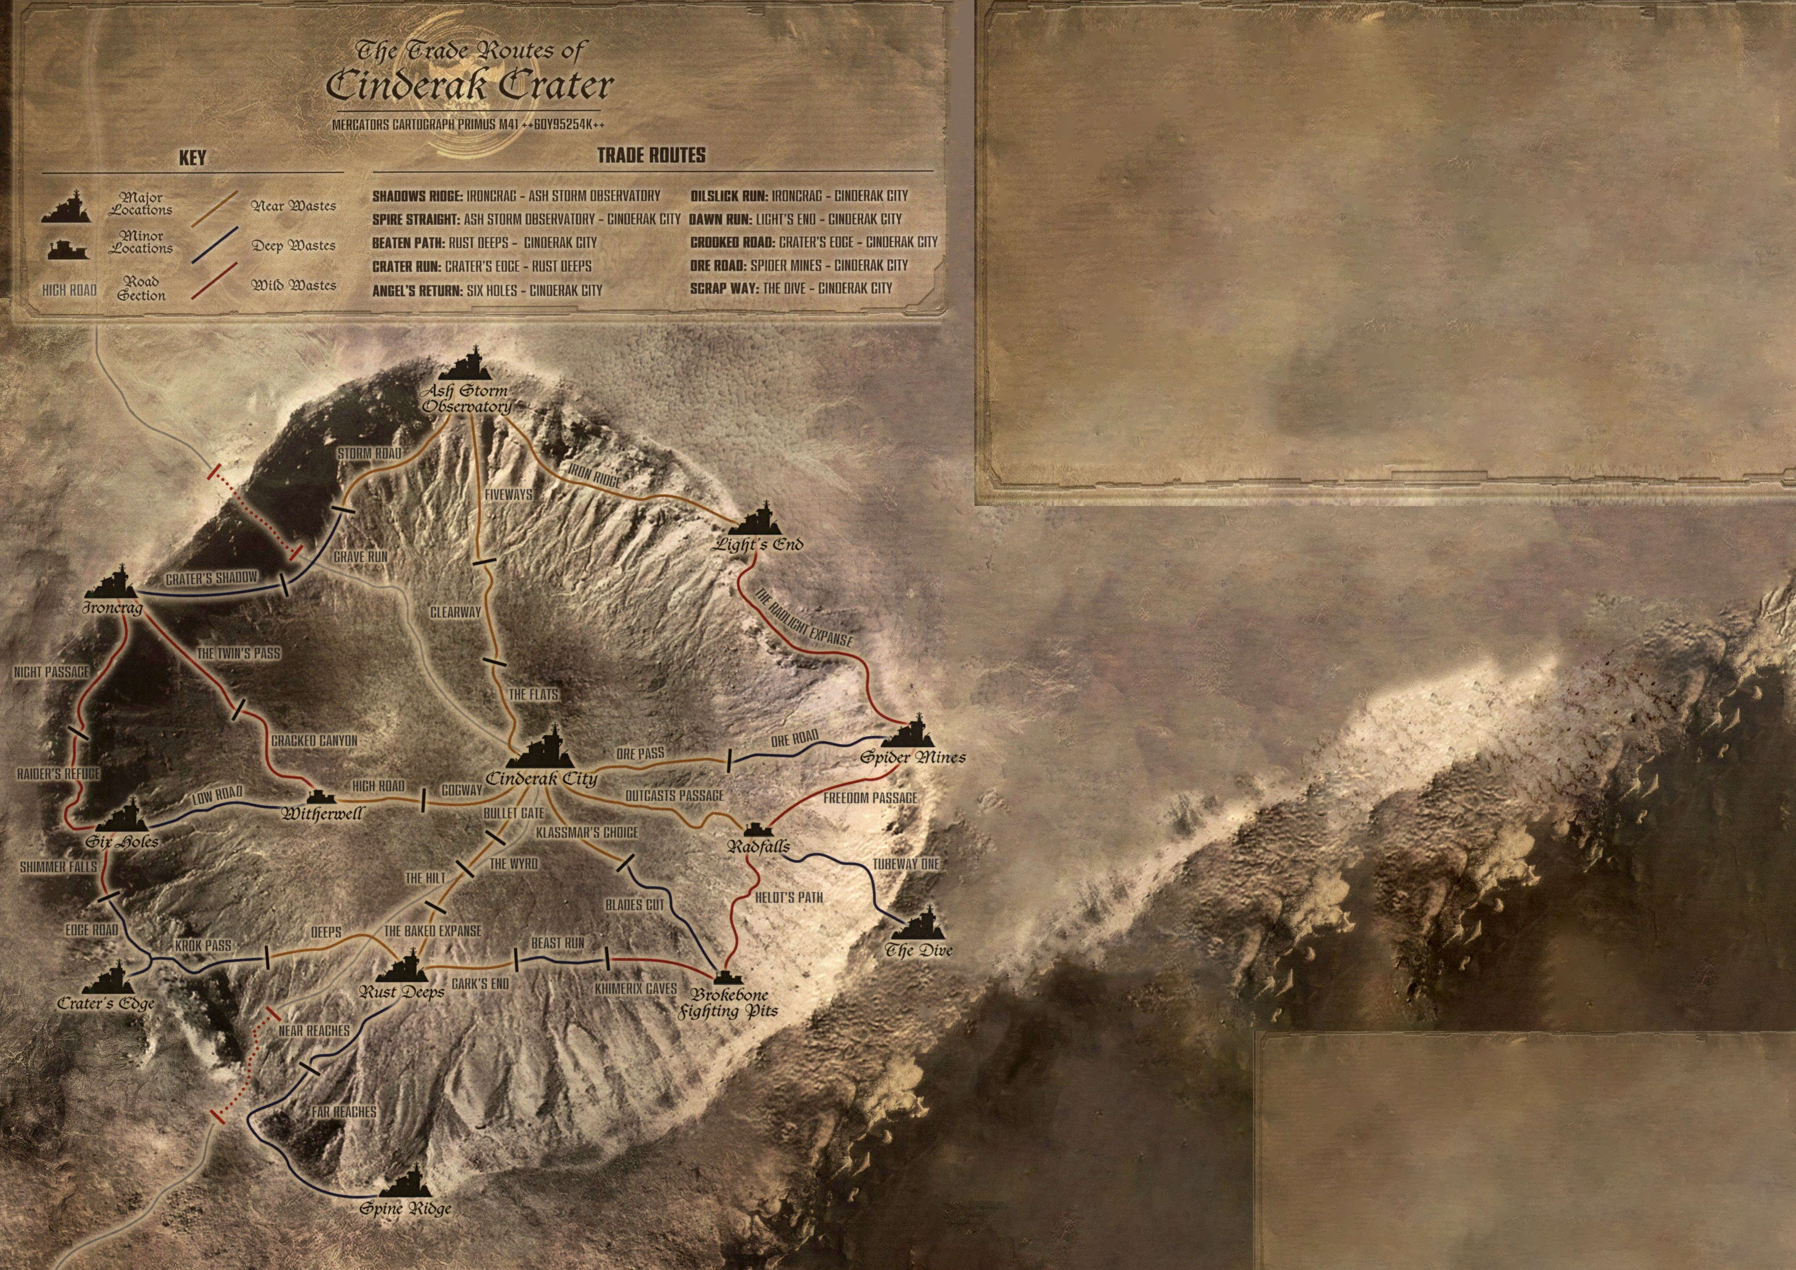
DX
TRADE ROUTES – STATUS RAPORT
++xxxxxxxxxxxxxxxxxxxxxxxxxxxxxxxxxxxxxxxxxxxxxxxccccc
+++ccccccccccccccccccccccccccccccccccc
++++xxxxxxxxxxxxxxxxxxxxxxxxxxxxx

You can take icons from there
And move them to the bottom box.
They can also be couloured, if more
Than 1 player has the same gang either
By changing colour or (more elegant
way) by changing glow colour
GANGS ACTIVITY

Escher
Delaque
Orlock
Venators
Palanite Enforcers
Corpse Grinder Cult

